Data flow digram (DFD) 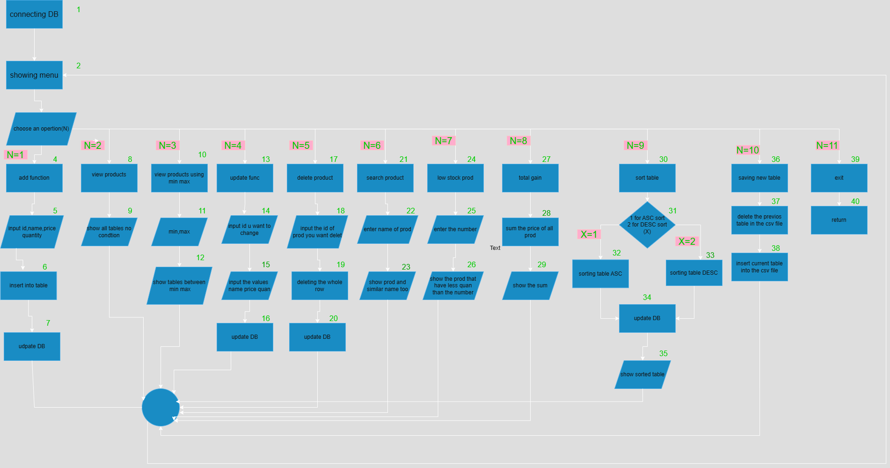

Test case 1 :

Input: input an N as 1 to add a new product name,id,price and quantity then input N as 2 to show the table with the new product you just added

Output:the out put after first N should be message to tell to enter data, after enter all needed data the second output should be the new table

Test case 2:

Input: N as 3 then enter the min max then 4 to update then 3 again to confirm the update function

Output: after you input 3 you should enter 2 values, the min max values and will be shown the table of products that price is between those 2 values then enter 4 to update info of a product that between the 2 values then press 3 again and enter the same min max to confirm the functionality of update function